*Semester One, 2018*

Question and Answer Booklet

**Year 10**

**Science**

***Time allowed for this paper***

Recommended Reading time: Ten minutes

Working time for paper: Eighty minutes

***Materials required/recommended for this paper***

This Question/Answer Booklet

Multiple-choice Answer Sheet

Periodic Table

Graph paper

**Students to provide:**

Standard items: pens, pencils, eraser, ruler, highlighters

Special items: non-programmable calculators satisfying the conditions set by the School

No other items may be taken into the examination room. It is your responsibility to ensure that you do not have any unauthorized notes or reference material. If you have any unauthorized material with you, hand it to the supervisor before reading any further.

Student Name: ________________________________

Class: _________

***Structure of this paper***

This paper requires students to answer 26 questions. The highest possible mark is 71. The candidate’s examination percentage will be calculated on the basis of the fraction of 71 examination marks scored by the candidate.

|  |  |  |  |  |
| --- | --- | --- | --- | --- |
| **SECTION** | **No. of questions available** | **No. of questions to be attempted** | **Suggested working time**  **(minutes)** | **Marks available** |
| Section 1:  **MULTIPLE CHOICE** | 20 | 20 | 25 minutes | 20 |
| Section 2:  **SHORT ANSWER** | 6 | 6 | 55 minutes | 51 |

***Instructions to candidates***

1. Answer the questions according to the following instructions.

Section One: Answer all questions on the separate Multiple-choice Answer Sheet provided. For each question cross the box to indicate your answer. Use only a blue or black pen to shade the boxes.

Section Two:  Write your answers in the space provided in this Question/Answer Booklet. Wherever possible, confine your answers to the line spaces provided. Use a blue or black pen (**not** pencil) for this section.

**SECTION ONE - MULTIPLE CHOICE** [20 marks]

This section has **20** questions. Answer **all** questions on the separate Answer Sheet provided. _______________________________________________________________________________________________________

1. Chromosomes are found in the nucleus of:

1. most cells of the body
2. brain cells only
3. gametes only
4. stem cells that have not yet differentiated

2. An allele is best defined as

1. a lethal recessive phenotype
2. a lethal dominant phenotype
3. a type of gene found only on the sex chromosome
4. an alternative form of gene at a given position on the chromosome.

3. What is the name given to an individual whose alleles are the **same** for a characteristic?

1. Heterozygous
2. Homozygous
3. Monohybrid
4. Homologous

4. The structure of DNA may be described as a twisted ladder. Recall what forms the upright parts of the ladder.

1. Alternating sugar and phosphate units
2. Nitrogen bases
3. Amino acids
4. Proteins

5. If a diploid cell in a plant has 32 chromosomes, how many chromosomes will be in each gamete?

1. 32
2. 30
3. 16
4. 14

6. Red-green colour-blindness is an X-linked recessive disorder. A mother with this condition and normal visioned father will pass this allele to:

1. her daughters only.
2. all of her children.
3. her sons only.
4. none of her children.

7. The periodic table:

1. is a systematic chart listing all known elements
2. arranges elements from lowest to highest atomic number
3. arranges elements in columns called groups
4. all of the above

8. An atom has a mass number of 27. It therefore has:

1. 13 protons, 14 neutrons and 14 electrons
2. 13 protons, 14 neutrons and 13 electrons
3. 14 protons, 14 neutrons and 14 electrons
4. 13 protons, 13 neutrons and 13 electrons

9. What is the name of the outermost shell in an atom?

1. Outer shell
2. Diatomic shell
3. Valence shell
4. Electronic shell

10. Which of the following is a noble (inert) gas?

1. Oxygen
2. Chlorine
3. Neon
4. Hydrogen

11. Which of the following is the **most** reactive metal element?

1. Potassium
2. Iron
3. Aluminium
4. Steel

12. Nitrogen is in period 2, group 15. Which of the following elements would have the most **similar** properties to nitrogen?

1. Phosphorus P (period 3, group 15)
2. Oxygen O (period 2, group 16)
3. Neon Ne (period 2, group 18)
4. Sodium Na, because its symbol also starts with N

13. Which of the following best describes the energy changes occurring when an apple falls from a tree branch to the ground below?

1. gravitational potential → kinetic → sound
2. gravitational potential l→ elastic potential 🡪 sound
3. kinetic → sound → gravitational potential
4. elastic potential → sound→ kinetic

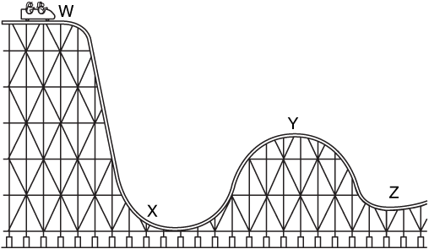Question **14** refers to the diagram of a rollercoaster below.

14. At which point on the rollercoaster does the cart have the **most** kinetic energy?

1. W
2. X
3. Y
4. Z

15. An object’s displacement is its position compared to its starting point. It has a size and a direction. A racehorse runs a race that starts and finishes at the same point. If the race was 1000 metres, what was the displacement of the horse when it finished?

1. 1000 metres
2. 500 metres
3. 10 metres
4. 0 metres

16. The racehorse now runs a second race but is unable to finish due to a sore leg and stops to a halt at a distance of 120 m east of the finish line. Given that the distance to be run in the race was 1000 m, and that the finish line was where the race started, the displacement of the racehorse is now:

1. 120 m east
2. 120 m west
3. 880 m east
4. 880 m west

17. Shown below is a displacement–time graph for Bob as he walks to a friend’s house and returns over a day.

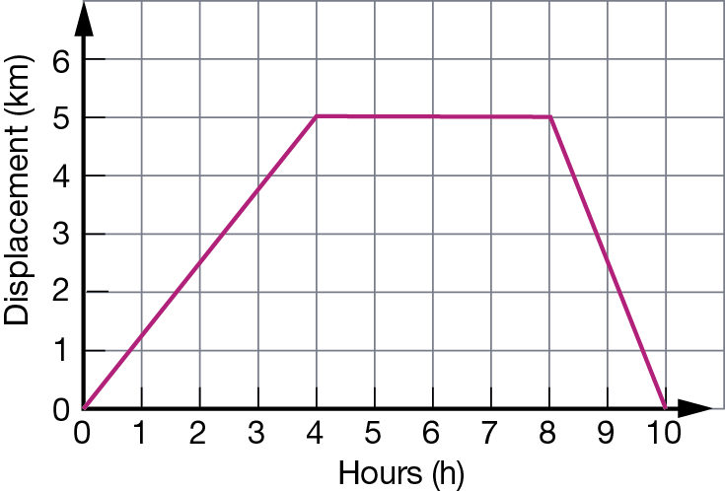

Which of the following statements concerning this journey is correct?

1. The total distance travelled for the journey was 5 km.
2. The total distance travelled for the journey was 10 km.
3. The total displacement for the journey was 5 km.
4. A one-hour rest break was made during the journey.

18. Three students, Jane, Indira and Charlotte run in a 100 m sprint on a school sports day. The displacement time graph of their motion is shown below.

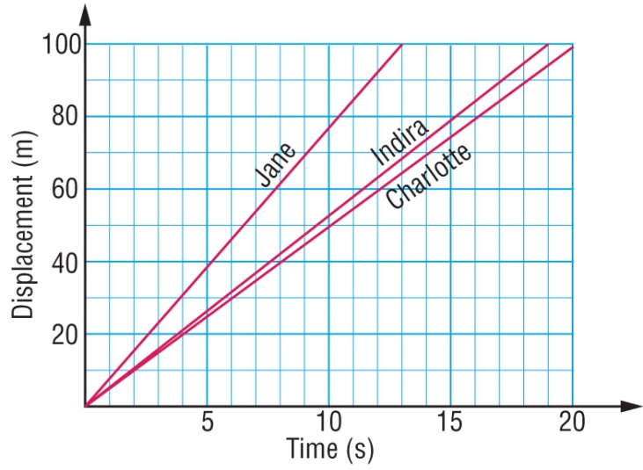

Select the alternative below that correctly orders their finish places in the race.

1. Jane wins, Indira is second and Charlotte is third.
2. Indira wins, Jane is second and Charlotte is third.
3. Charlotte wins, Indira is second and Jane is third.
4. Charlotte wins, Jane is second and Indira is third.

19. The greater the rebound height of a ball, the greater is the efficiency of energy transfer from gravitational potential to kinetic energy. Five balls are all dropped from a height of 2.0 m. The rebound height of each is listed in the table below.

|  |  |
| --- | --- |
| **Type of ball** | **Rebound height (m)** |
| Basketball | 1.42 |
| Tennis ball | 1.55 |
| Squash ball | 0.05 |
| Cricket ball | 0.68 |

The type of ball that transferred gravitational potential energy to kinetic energy the most efficiently in this test was the:

1. Basketball
2. Tennis ball
3. Squash ball
4. Cricket ball

20. The efficiency of a ball is the ratio of the rebound height and the height dropped. Use the table in the previous question to select the likely efficiency of the four balls tested.

|  |  |  |  |  |
| --- | --- | --- | --- | --- |
|  | **Efficiency of basketball** | **Efficiency of tennis ball** | **Efficiency of squash ball** | **Efficiency of cricket ball** |
| a) | 2.5 % | 34% | 78% | 71% |
| b) | 78% | 2.5% | 34% | 71% |
| c) | 34% | 71% | 78% | 2.5% |
| d) | 71% | 78% | 2.5% | 34% |



**Year 10**

**Science**

**Semester 1 Exam 2018**

**MULTIPLE CHOICE ANSWER SHEET**

**NAME:**

**FORM: DATE:**

**SECTION ONE: Multiple choice answers**

**Cross (X) through the correct answer.**

|  |  |  |  |  |  |  |  |  |  |  |
| --- | --- | --- | --- | --- | --- | --- | --- | --- | --- | --- |
| **1** | **a** | **b** | **c** | **d** |  | **13** | **a** | **b** | **c** | **d** |
| **2** | **a** | **b** | **c** | **d** |  | **14** | **a** | **b** | **c** | **d** |
| **3** | **a** | **b** | **c** | **d** |  | **15** | **a** | **b** | **c** | **d** |
| **4** | **a** | **b** | **c** | **d** |  | **16** | **a** | **b** | **c** | **d** |
| **5** | **a** | **b** | **c** | **d** |  | **17** | **a** | **b** | **c** | **d** |
| **6** | **a** | **b** | **c** | **d** |  | **18** | **a** | **b** | **c** | **d** |
| **7** | **a** | **b** | **c** | **d** |  | **19** | **a** | **b** | **c** | **d** |
| **8** | **a** | **b** | **c** | **d** |  | **20** | **a** | **b** | **c** | **d** |
| **9** | **a** | **b** | **c** | **d** |  |  |  |  |  |  |
| **10** | **a** | **b** | **c** | **d** |  |  |  |  |  |  |
| **11** | **a** | **b** | **c** | **d** |  |  |  |  |  |  |
| **12** | **a** | **b** | **c** | **d** |  |  |  |  |  |  |

**SECTION TWO - SHORT ANSWER SECTION**  [51 marks]

This section has **6** questions. Answer **all** questions in the spaces provided. __________________________________________________________________________________________________________

**Question 1.**

* 1. Complete the following table: (4 marks)

|  |  |  |  |
| --- | --- | --- | --- |
| ELEMENT | ATOMIC NUMBER | ELECTRON SHELL DIAGRAM | ELECTRON CONFIGURATION |
| Oxygen | 8  (1/2 mark) | (1 mark) | 2, 6  (1/2 mark) |
| Oxide ion | 8  (1/2 mark) | ( 1/2 Mark for the 8 in the valence shell, other half for the bracket and charge) | 2, 8  (1/2 mark) |

* 1. Identify **two differences** between the alkali metals and the noble gases:

(4 marks)

|  |  |
| --- | --- |
| Alkali metals | Noble gases |
| One electron in outer shell  Usually in solid form  Group 1  Highly reactive  (1 mark for any of above, 2 marks max) | Full and stable outer shell  Gaseous form  Group 18  Not reactive at all  (1 mark for any of above, 2 marks max) |

* 1. Classify the following substances according to the types of bonds present (3 marks)

$2 coin _________________Metallic_________ table salt _________Ionic______________

carbon dioxide ____________Covalent_____________

**Question 2.**

Consider the following pedigree for hair colour in mice. Mice can have either black coats (B) or brown coats (b). Black coats are dominant to brown.



Male Female

1. What is the genotype for brown coats? ______________bb__________________ (1 mark)
2. Which individuals have brown coats? _________________4,10________________ (1 mark)
3. How are individuals 10 and 11 related to each other? _________siblings- brother and siste__________________ (1mark)
4. Individuals 6 and 7 are 'carriers' of the brown allele. What is meant by the term carrier?

(2 marks)

The term carrier describes an organism that carries two different forms (alleles) of a recessive gene (alleles of a gene linked to a recessive trait) and is thus **heterozygous for that the recessive gene**. – **1 mark for recessive trait, having the allele, other mark for don’t have the condition however can pass it on.**

**Question 3.**

Having dimples (D) in your cheeks is dominant to having no dimples (d).

1. Write the possible genotypes and phenotypes for this trait. (3 marks)

Genotypes Phenotypes

½ mark each correct answer

DD Dimples

Dd Dimples

dd No Dimples

A heterozygous man, who has dimples, has children with a woman with no dimples.

1. Draw a Punnett square to show the potential offspring these two individuals can produce.

(2 marks)

|  |  |  |
| --- | --- | --- |
|  | D | d |
| d | Dd | dd |
| d | Dd | dd |

(1 mark for correct parent genotype, 1 mark for correct child possible genotypes)

1. What is the probability (%) that they produce a child with no dimples? ____50%_____

(1 mark)

1. Circle the correct response which occurs either before or after the forward slash. (3 marks)

Dimples is an example of a **dominant**/recessive trait

The child with no dimples produced in question (c) is

**homozygous**/heterozygous

Incomplete/**Codominance** is when both traits are dominant and displayed separately in the phenotype

1. The gene for coat colour in cats is carried on the X chromosome. There are two alleles, black (B) and orange (O). These two alleles are codominant.

The genotypes of XBXB and XBY result in black cats

The genotypes of XOXO and XOY result in orange cats

The genotype of XBXO results in a tortoise shell cat

A female tortoise shell cat produces in her litter 1 black female, 3 tortoise shell females, 1 black male, and one orange male. Determine **the genotype of the father** **cat** using a Punnett square to support your answer (4 marks)

|  |  |  |
| --- | --- | --- |
|  | XB | XO |
| XB | XB XB | XB XO |
| Y | XB Y | XO Y |

The father is a black cat XB Y – 1 marks

1 mark each for correct genotype of parents

1 mark for correct genotypes of offspring

**Question 4.**

Give one word or term for each of the following descriptions. Write only the word or term next to the question number. (4 marks)

1. A soccer ball at rest is then kicked across the field. This is an example of an energy…

____transfer___

1. Someone turns on a light switch (which began as electricity and is seen as light) is an example of an energy….

________Transformation__

1. State the law of conservation of energy:

**Energy** can neither be created nor destroyed, (1/2 mark) but can be transferred or transformed . (1/2 mark)

1. What is the formula for calculating energy efficiency ?

 (1 mark) energy output need useful output

**Question 5.**

Car racing is very popular in Australia. Many young people want to test the speed of their cars and meet regularly at racetracks. An oval racetrack has a lap distance of 2 000 m. The car has to complete 5 laps.

a) In one of the races a car has a running start. The timekeeper starts the stopwatch as the car passes the starting point. The results are shown in the table below.

|  |  |
| --- | --- |
| Number of laps | Time (s) |
| 1 | 55 |
| 2 | 110 |
| 3 | 165 |
| 4 | 275 |
| 5 | 385 |

On the graph paper provided **draw a graph** of the number of laps (on the dependent y-axis) versus time (on the independent x-axis) for the car's run.

Plot the points and connect them with straight lines. Also supply a suitable heading.

-1/2 mark **for each** problem, ie no title, no axis title, no axis unit, no pencil, no ruler, incorrect scale, inaccurate plots, not connected to zero (yes graph is wrong)

Axis should also be the other way around unlike shown in this graph! (5 marks)

b) Use your graph to determine how long the car took to complete 2.5 laps. Indicate on your graph how you obtained this value. (2 marks)

125 - 130 seconds to complete 2.5 laps (1 mark) ½ correct number ½ unit

Line from 2.5 up to line graph (1/2), then a line from line graph to time on y axis 1/2) (Total1 mark)

c) How does the motion of the car during the first three laps compare with its motion in

the last two laps? Its slower, building up speed at a slower rate (1 mark)

**Question 6.**

**Work= f** x **d Gravitational Potential Energy (J) = m** x **g** x **h** where g=9.8 m/s

**Kinetic Energy = 0.5 x m x v2**

1. An elastic band is stretched back and then released. It travels a distance of 5 metres. If the force required to pull the elastic band was 5 Newtons, calculate the amount of work done. Show your working. (2 marks)

W = f x d

= 5 x 5 (1 mark)

= 25 J or Joules (1 mark for correct answer AND correct unit of measurement)

1. Tony the firefighter has a mass of 90kg. He climbs up a 7 metre ladder to rescue a cat. Calculate his gravitational potential energy. Show your working. (2 marks)

GPE = m x g x h

= 90 x 9.8 x 7 (1 mark)

= 6174 J or Joules (1 mark for correct answer AND correct unit of measurement)

1. A bullet of mass 80 g that leaves a rifle with 250J of kinetic energy. Calculate the velocity of the bullet as it leaves the rifle. (3 marks)

**KE= ½ x m x v2**

**250= ½ x 0.08 x v2 (1 mark)**

**square root of 250/0.5x0.08 square root of 250/0.04 square root of 6250 1 mark for any of the rearranging steps**

**Answer = 79.06 m/s ( ½ mark correct number, ½ mark unit) If don’t convert to Kg and get answer should be 2.5 take ½ mark off**

1. A washing machine loses 134J of energy when supplied with 1832 J. Calculate the efficiency of the washing machine and state why the efficiency isn’t 100%. (3 marks)

Energy efficiency = useful output x 100%

Total input

EE= 1832-134 x 100% ( 1 mark)

1832

EE = 92.7 % ( 1 mark- ½ each for correct number and %)

Energy is lost as wasted energy due to friction of moving parts(1/2) generating heat (1/2 mark)

**END OF PAPER**